* **Type of engineers**

## **1. Aerospace Engineering**

Aerospace engineers work to develop things that fly-airplanes, spacecraft, missiles, and so on. They do so by incorporating physics principles such as lift, drag, and thrust.

**2. Agriculture & Food Engineering**

These engineers are all about food, not unlike myself. Except I just eat it. Food engineers help design systems for producing, storing, and distributing it.

**3. Architectural Engineering**

Architectural engineers are tasked with designing buildings, preferably ones that won’t fall down. To achieve this, they study things like the strengths of various building materials, how to make buildings withstand earthquakes and high winds, how different soil types affect the stability of a building, and so on.

**4. Automotive Engineering**

Automotive engineers design the cars, trucks, SUV’s, and vans that

you and I drive on a daily basis. They use their knowledge of things like aerodynamics, material densities, and even software and electronics applications to design everything from the physical shapes .

**5. Biomedical Engineering**

If you’ve ever been to a hospital, you’ve seen the work of this group. Biomedical engineers are the ones who design the devices and instrumentation used in the healthcare industry. Everything from prosthetic limbs to CPAP machines have been developed by biomedical engineers.

**6. Biotechnology Engineering**

Biotechnology engineers use principles from biochemistry to develop things like medicine, cell and tissue cultures used in research, and even art! Seriously, do a google search for “bio-art” and you can thank me later. Like biomedical engineers, biotechnology engineers study ways to keep us alive and healthy.

Top of Form

:

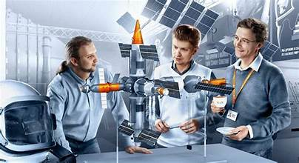Bottom of Form